**1. INTRODUCTION**

The procedures and rules set forth in the following pages are for the guidance of undergraduate students preparing reports. These materials are not intended however, as a complete manual for the writing of reports. The student should consult those which are relevant to his/her field of study. As to the specific requirements, those listed herein should be followed.

**2. GENERAL INSTRUCTIONS**

Follow the departmental deadlines for submitting the reports

**3. FORMAT**

* 1. **Character Fonts**

As a character font use Times New Roman. The font size must be 12 in text including formulae, equations, table headings and figure captions. At least 8 point should be used in figures, tables and, subscripts. Footnotes, long biographical quotes and extensive quotations should be 10 points.

* 1. **Spacing**

Spacing or the text material shall be 1.5 or when necessary integer multiples thereof. For example when a paragraph ends, the next one starts after pressing RETURN twice

(2×CR) to get 1.5 spacing.

The followings are exceptions:

* Footnotes - single spacing
* Long biographical quotes – single spacing
* Extensive quotations - single spacing and indented one (1) centimeter relative to the text material.
  1. **Left Adjusting**

The left adjusting point of titles and headings shall be 3.5 mm from the left edge of the paper. You can use the appropriate left adjusting command in computer typesetting.

**3.4 Margins**

Margins of pages shall conform to the following specifications:

Left margin - 3.5 cm from edge of paper

Right margin - 2 cm from edge of paper

Top margin - 3.5 cm from edge of paper

Bottom margin - 2 cm from edge of paper

The above margins shall be observed on charts, graphs, tables and drawings. Folded papers will not be accepted unless there is absolutely no other way for the material to be presented.

**3.5 Pagination**

Each page in the report (except the title page) is expected to bear a number. Only one side of the paper may be used. The preliminary section, including the title page; copyright page, if any; foreword, preface, or acknowledgements; table of' contents, etc., should be numbered, using lower case Roman Numerals, e.g., i, ii, iii, etc. The title page counts as Page i, but the number does not appear. The sequence of the preliminary section is as follows:

Title Page Page i number does not appear

Page of Approval Page ii

Copyright Page iii

Foreword, Preface or Acknowledgements Page iv as necessary

Abstract Page v as necessary

Table of Contents Page vi, vii as necessary

List of Figures Page viii, ix as necessary

List of Tables Page x, xi as necessary

List of Symbols/Abbreviations Page xii, xiii as necessary

For the remainder of the report, Arabic numbers are used. Each page must be numbered. Page numbers are to be placed two centimeters from the top and right hand margins on the page and must be 12 point. Include all pages for i1lustrations, tables, appendices, bibliography, etc. Use of suffixes, such as 25a, 25b, etc., will not be approved. The numbering in the main body of the report should begin with Page 1 and run consecutively to the last page. No punctuation, such as dash or a period, should accompany the page number. Paragraphs must be uniformly indented one centimeter. Series of paragraph items which are to be listed without headings under any of the regular headings may, for clarity, be designated by special bullets such as ., or enumerated by (i), (ii), (iii), etc. A new paragraph must not begin at the bottom of a page if there is not sufficient space for at least (2×CR). A paragraph must be separated from the preceding and succeeding paragraphs by (2×CR).

**3.6 Heading**

**3.6.1. Main Headings**

Main headings numbered such as 1, 2, etc. must obey the following rules:

* They must begin a new page according to Section 3.3. Omit period at the end of the heading. Main headings must be typed in bold face and must be in capital letters and in 14 points.
* Main headings should reflect content of the text that follows. Main headings are not to be called as chapters. .
* The number of the headings will be followed by a period and two spaces.
* They must precede the following text material or second heading by (3×CR).

**3.6.2. Second Headings**

Second headings numbered such or 2.1., 2.2., etc. must obey the following rules:

* They must begin according to Section 3.3 be typed in 12 points, bold face and, capital and lower case lower case letter ; i.e., the first letter of each words except conjunctions, prepositions and articles must be a capital letter. Omit period at the end of heading.
* The number designation of second heading will be followed with a period and two spaces.
* Second headings must be (2×CR) below preceding text and (2×CR) of succeeding text, but need not a new page.

**3.6.3. First Subheadings**

First subheading numbered such as 2.1.1., 2.1.2., etc, must obey the following rules:

* They must be typed on separate lines beginning at the left margin line of the text but need not begin a new page.
* They must be typed in bold face and with capital and lower else letters except, conjunctions, prepositions and articles.
* The number designation of the heading will be followed by a period and two spaces. Omit period at the end of the heading.
* First subheadings must be separated from the preceding and succeeding text by (2×CR).

**3.6.4. Second Subheadings**

Second subheadings numbered such as 2.1.1.1., 2.1.1.2., etc. must obey the following rules; however, second subheadings should be avoided if possible.

* They must be typed on the same line as the text it introduces, beginning at the left margin line of the text.
* They must be typed in capital and lower case letters except conjunctions, prepositions and articles.
* They must be followed by a period at the end of the heading and must be underlined.
* The number designation shall be followed by a period and two spaces.
* Second subheadings must be separated from the preceding text by (2×CR).

**3.7. Footnotes**

Footnotes should obey the following rules; however, footnotes should be used only if absolutely necessary:

* Footnote references shall be indicated in the text by an Arabic number placed superior to the text and immediately following the word, phrase or sentence which the footnote concerns.
* Footnotes shall be sequential for each page and for the entire report.
* Footnotes shall be placed at the bottom of the page on which they are indicated. They shall be indented from the left margin of the text by one centimeter and placed under a broken line made of 20 characters (5 cm). Footnotes single-spaced and 10 points.

**3.8. Bibliographical Material**

As already noted in the introduction, reports should follow the form used in scholarly publications of the student's field of job. Rules of form vary from one field to another, and it is important that the student learn the editorial usages of his/her own field, It is generally important that he/she follow such usages consistently throughout his/her report.

* The number in square brackets such as "[8]”, should indicate the order or first appearance of the reference in the text. The listing of references in the bibliography shall be in the order in which they are used in the text and shall bear the same number as was used in the reference in the text. (See Page 16).

**3.9. Specially Designated Expressions**

Specially designated expressions usually mean equations, formulae, etc. and they obey the following rules:

* They will be centered on the page according to Section 3.3 and separated from the preceding text and the succeeding text by (2×CR).
* The expressions shall be identified by an Arabic number in parentheses like

"(2.1)", "(2.2)", "(2.3)", etc., which should be placed opposite the expression and in line with the right margin of the text: They should be numbered within each chapter in the order of their appearance.

* Mathematical formulae and expressions must be typeset according to a consistent math-style throughout the whole report. The standard style for mathematical expressions in scientific publication makes use of italic typeface for vectors and matrices. In Latin characters and non-italic typeface for mathematical signs (+, -, parentheses, etc.). Bold characters are usually reserved for vectors and matrices. In any case, the style used for in-text formulae should be the same as that of displayed formulae.

**3.10. Tables and Figures**

In general, all of these are special matters, usually of a technical sort, and the proper form must he understood and followed after a received instructions from his/her supervisor. To ensure satisfactory reproduction, drawings, graphs etc., they should be prepared in contrasting colors, preferably in black. Tables and figures should be enumerated within each chapter, i.e., as 2 .1, 2.2, 2.3, 3.1, 3.2, etc. The designation or each table or figure within the text should have only the first letter in capital (i.e. such as "Table 4.5" or "Figure 3.8") throughout the report (See Page 14): Tables, figures and their captions should be centered. The captions should be as normal text, i.e. only the first letter should be capitalized. The captions should be at a distance of (1×CR) from the table or figure. Also note that all floating items such as graphs, charts, photographs and illustrations should be considered and designated as a figure or table, whichever is appropriate.

**4. ARRANGEMENT**

**4.1. Title Page**

When preparing the Title Page, the candidate must list his/her prior degree(s) showing the major, the degree granting institutions and dates in chronological order. This page does not bear a page number. Examples of Title Page for a report are presented on Pages 10. Follow the examples carefully as to form and spacing. At the bottom of the example pages where year is shown, write the semester date in which the requirements for the degree were completed.

**4.2. Approved Page**

All copies of the report submitted must include original signatures of tile Examining Committee on the approval page. It should be prepared in accordance with the sample in Page 11 and should follow the title page. The names of the members of the Examining Committee will be listed one below the other in alphabetical order except the Supervisor's, whose will be at top of the list. Beside each name, space for the signature of each examiner should be left. The date at the bottom of the page is the date the report was approved by the Examining Committee.

**4.3. Dedication**

Occasionally, authors would like to dedicate their report to their family members, friends or some scientists in their area of research. The dedication page should follow right after the Approval Page.

**4.4 Acknowledgements**

The candidate may desire to include a page with a brief note of an acknowledgement of help received from particular people. All organizations proving financial support must also be acknowledged, with project identifications like grant number etc.

**4.5. Abstract**

The abstract should give the information that will enable a student to tell whether he/she wishes to read the complete work. Therefore, the abstract should cover the following points: Statement of the problem, procedure or method, results, conclusions. The abstract should contain no headings tabular material, chemical formulas, or footnotes. Abstracts should not contain references, but author citing is allowed.

**4.6. Table of Contents, List of Figures, Tables and Symbols / Abbreviations**

Reports are expected to have a "Table of Contests for the convenience of the reader. If figures and tables are scattered throughout the text a separate "List of Figures" and/or "List of Tables" must be included after the Table Contents. These lists should include after the Table of Contents. These lists should include page numbers. Similarly, a "List of Symbols" (or "List of Symbols/ Abbreviations" as appropriate) should be included. Examples of such materials are shown on Pages 14-15. "List of Symbols /Abbreviations" can contain abbreviations listed alphabetically as a separate group following the symbols.

**4.7. Text**

The text of the report will follow at this point. The first chapter (in most cases, Introduction) will start on the first page of the text, i.e. the first page enumerated in Arabic numerals. When writing your report, pay attention to some of the precautions listed below:

* The whole text should be left and right Justified.
* Please note the spelling of "Foreword".
* Periods, commas, semicolons and colons go outside the quotation marks.
* The word "data" is plural and requires a plural verb.
* Integers from one to nine, inclusive, should be spelled out except when they represent a chapter or a section; for number 10 and above, use numerals. Numbers should be spelled out when they begin a sentence.
* Spell out per cent: do not use %, and write per cent as two words without a period within the text.

**4.8. Appendices**

A last section may contain supporting data for the text in the form of one or more appendices. Examples of appendix material include data sheets, questionnaire samples, flowcharts, illustrations, maps, software listings, charts, etc. If a section, table, figure, equation etc., is to be included in an appendix, the numbering should follow the same rules used within the report. In this case, however, they should begin with the letter of the respective appendix such as "Table A.l", "Equation (B.4)" etc. Each appendix should have a descriptive title just like chapter headings. The developed computer program should be given in a separate diskette or CD. The format and contents of this CD is explained in Appendix B of this booklet.

**5. PREPARATION OF THE FINAL COPIES**

**5.1. Typesetting**

Computer typesetting programs reports written in MS- WORD for Windows, Open Office are acceptable.

**5.2. Paper Quality**

The original copy shall be typed on A4-size white paper. All reproduced copies should be of the same grade of paper.

**5.3. Printer**

Only laser printer and Ink Jet printer output are acceptable. Printer settings must comply with A4-size paper and must be so that the page is not resized in printing.

**5.4. Reproduction**

Mimeographed or ditto copies are not acceptable for the Institute or Library copies; however, photocopy reproduction is acceptable for all parts or copies of the report. Care must be taken to insure that the proper grade of paper is used at all times and that copying contrast is dark.

**5.5. Binding**

The report should be bound in hard cover. Binding, must preferably be press binding or at-least tape binding with plastic cover. In any case, spiral binding is not allowed. The final bound size of the report should conform to A4 size. The name and surname of the candidate, the degree and the year should be printed in the above order on the spine of the cover. When the report is placed front cover up, the spine should read from left to right. The format of the front cover is depicted on Page 17.

**APPENDIX A: SAMPLE PAGES**

The following pages present examples of some report pages typeset in the format described earlier. They include the pages to be found in the preamble of report (such as title and approval pages, table of contents, etc,), as well as examples of list of references and the abstract to be submitted separately to the Institute, Also the format of the cover for the bond copy is shown. The sample pages for reference list include examples of referencing journal articles, books, articles in a book, reports, conference papers, reports and articles in the Internet. Follow the examples in the following pages carefully as the form, font type and size, and spacing is concerned.



TRIBHUVAN UNIVERSITY

INSTITUTE OF ENGINEERING

PULCHOWK CAMPUS

**(PROJECT REPORT TITLE)**

By:

**(name(s) of students)**

A PROJECT WAS SUBMITTED TO THE DEPARTMENT OF ELECTRONICS AND COMPUTER ENGINEERING IN PARTIAL FULLFILLMENT OF THE REQUIREMENT FOR THE BACHELOR’S DEGREE IN ELECTRONICS & COMMUNICATION / COMPUTER ENGINEERING

DEPARTMENT OF ELECTRONICS AND COMPUTER ENGINEERING

LALITPUR, NEPAL

MONTH, YEAR

**Format of approval page**

TRIBHUVAN UNIVERSITY

INSTITUTE OF ENGINEERING

PULCHOWK CAMPUS

DEPARTMENT OF ELECTRONICS AND COMPUTER ENGINEERING

The undersigned certify that they have read, and recommended to the Institute of Engineering for acceptance, a project report entitled "Title of the Project" submitted by Name of Student(s) in partial fulfilment of the requirements for the Bachelor’s degree in Electronics & Communication / Computer Engineering.

_________________________________________________

Supervisor, name of Supervisor

Title

Name of the Department

__________________________________________________

Internal Examiner, name of Internal Examiner

Title

Name of the Organization, he belongs to

__________________________________________________

External Examiner, name of External

Title

Name of the Organization, he belongs to

------------------------------------------------------------------------------

Coordinator, Name of Coordinator

Title

Name of the coordinating committee

**DATE OF APPROVAL:** Day.Month.Year

**COPYRIGHT**

The author has agreed that the Library, Department of Electronics and Computer Engineering, Pulchowk Campus, Institute of Engineering may make this report freely available for inspection. Moreover, the author has agreed that permission for extensive copying of this project report for scholarly purpose may be granted by the supervisors who supervised the project work recorded herein or, in their absence, by the Head of the Department wherein the project report was done. It is understood that the recognition will be given to the author of this report and to the Department of Electronics and Computer Engineering, Pulchowk Campus, Institute of Engineering in any use of the material of this project report. Copying or publication or the other use of this report for financial gain without approval of to the Department of Electronics and Computer Engineering, Pulchowk Campus, Institute of Engineering and author’s written permission is prohibited.

Request for permission to copy or to make any other use of the material in this report in whole or in part should be addressed to:

Head

Department of Electronics and Computer Engineering

Pulchowk Campus, Institute of Engineering

Lalitpur, Kathmandu

Nepal

**TABLE OF CONTENTS**

PAGE OF APPROVAL.................................................................................................II

COPYRIGHT...............................................................................................................III ACKNOWLEDGEMENTS.........................................................................................IV

ABSTRACT..................................................................................................................V

TABLE OF CONTENTS.............................................................................................VI

LIST OF FIGURES....................................................................................................VII

LIST OF TABLES....................................................................................................VIII

LIST OF SYMBOLS AND ABBREVIATIONS........................................................IX

1 INTRODUCTION.......................................................................................................1

1.1 Sub-heading..................................................................................................1

1.2 Sub-heading..................................................................................................2

1.3 Sub-heading..................................................................................................3

2 LITERATURE REVIEW............................................................................................4

2.1 Sub-heading..................................................................................................5

2.1.1 Sub Sub-heading...........................................................................7

2.1.2 Sub Sub-heading...........................................................................8

2.1.3 Sub Sub-heading.........................................................................10

2.2 Sub-heading................................................................................................13

2.2.1 Sub Sub-heading.........................................................................14

3 OTHERS HEADINGS..............................................................................................16

3.1 Sub-heading................................................................................................16

3.1.1 Sub Sub-heading.........................................................................18

.

.

4 RESULTS......…………………………....................................................................30

5 CONCLUSIONS AND FURTHER WORK.............................................................32

5.1 Conclusions................................................................................................32

5.2 Further Work..............................................................................................33

REFERENCES ............................................................................................................34

APPENDIX A: Title of Appendix...............................................................................37

APPENDIX B: Title of Appendix................................................................................38

**LIST OF FIGURES**

Figure 1.1 System Overview..........................................................................................1

Figure 2.1 Intersection of two lines................................................................................6

Figure 2.2 Intersection of two lines in 3D......................................................................6

Figure 2.3 Intersection of N lines...................................................................................7

Figure 2.4 Single Camera...............................................................................................7

Figure 2.5 Stereo Camera Geometry..............................................................................8

Figure 3.1 Image and it’s SIFT features.........................................................................9

Figure 3.2 Determining stable keypoints.....................................................................10

Figure 3.3 Corner extractions for camera calibration...................................................11

Figure 3.4 Cameras mounted on the board..................................................................12

Figure 3.5 Matching right figure with left one.............................................................13

Figure 3.6 Test System.................................................................................................14

**LIST OF TABLES**

Table 3.1 Calibration result of first camera..................................................................11

Table 3.2 Calibration Data...........................................................................................20

**LIST OF SYMBOLS / ABBREVIATIONS**

θ Orientation Vector

p Position Vector

SIFT128 The 128-dimension SIFT descriptors

2D 2 Dimensional

3D 3 Dimensional

ASCII American Standard Code for Information Interchange

CCD Charge Coupled Devices

FPGA Field Programmable Gate Array

PGM Portable Gray Map

RANSAC RANdom SAmple Consensus

SIFT Scale Invariant Feature Transform

SURF Speeded Up Robust Features

SVD Singular Value Decomposition

**REFERNCES**

1. M. Betke, L.Gurvits, “Mobile Robot Localization Using Visual Landmarks,” *IEEE Transaction**on Robotics and Automation,* Vol.13, No.2, pp. 251-263, 1997.
2. R. Sim, G. Dudek, “Mobile robot localization from learned landmarks,” *In Proceedings of the International Conference on Intelligent Robots and Systems*, Vol.2, pp. 1060-1065, 1998.
3. S. Thrun, “Finding landmarks for mobile robot navigation,” *In Proceedings of the*

*International Conference on Robotics and Automation,* Vol. 2, pp. 958-963, 1998.

1. Desouza, G. N., Kak, A. C., “Vision for mobile robot navigation: a survey” *IEEE Transaction on Pattern Analysis and Machine Intelligence*, Vol.24, No.2, pp.237-267, 2002.
2. D.G. Lowe, “Object recognition from local scale invariant features”, *In Proceedings of the Seventh International Conference on Computer Vision*, pp.1150-1157, September 1999.
3. R.Hartley, A.Zisserman, “Multiple View Geometry in Computer Vision”, *Cambridge University Pre*ss, 2000.
4. D. Lowe, “Distinctive Image Feature from Scales-Invariant Keypoints,” *International Journal of Computer Vision*, pp. 91-110, 2004.
5. R. Cipolla, P. J. Giblin, “Visual Motion of Curves and Surface”, *Cambridge University Press*, 2001.
6. D.G. Lowe “Demo Software: SIFT Keypoint Detector”, <http://people.cs.ubc.ca/~lowe/keypoints/>, 2005.
7. J. Bouguet “Camera Calibration Toolbox for Matlab”, http://www.vision.caltech.edu/bouguetj /calib_doc/, 2008.

**Format of the Cover**

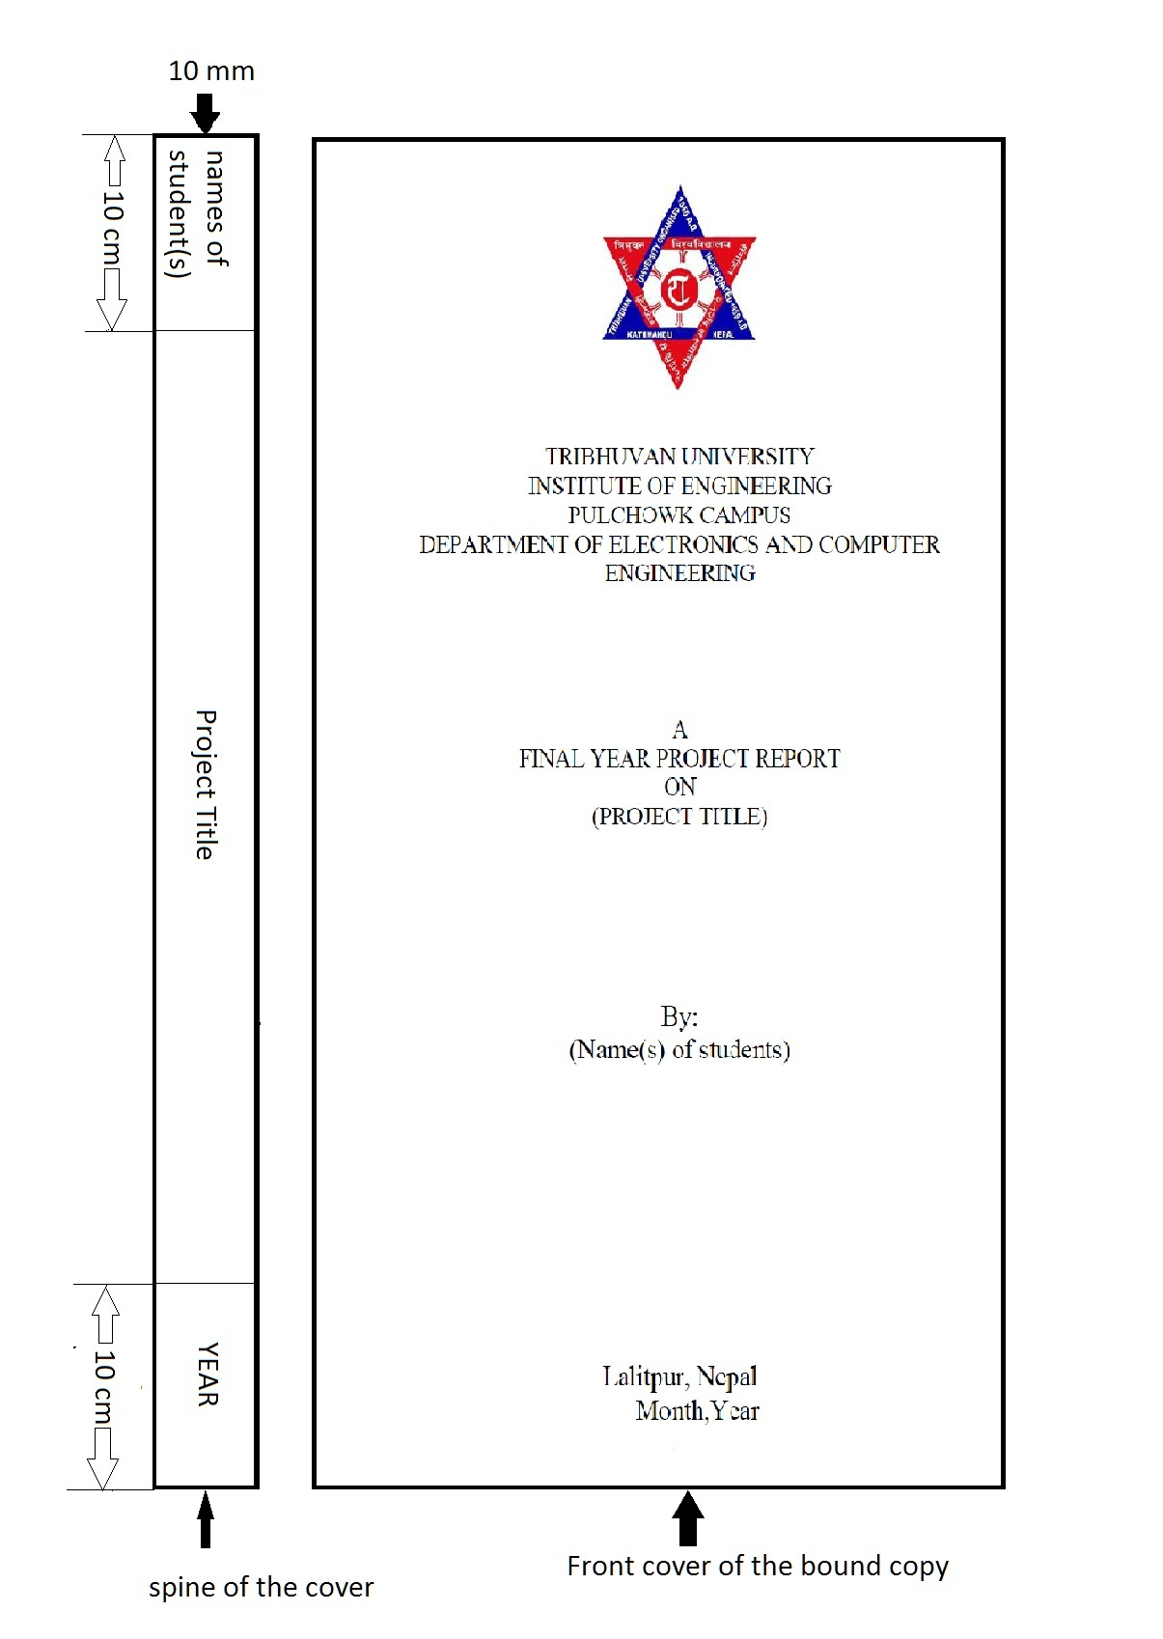

**APPENDIX B: FORMAT OF DISKETTES/CD CONTAINING COMPUTER SOFTWARE**

Listings of software should be given in a diskette/CD. The diskette/CD should contain files containing the source code, one or more sample input and corresponding output separately. Other than there, there must be another file named “README”. In this ASCII text file, the following sections must appear:

* Files in the Disk: In this section, the names of the files together with their contents must be listed.
* Hardware Requirements: In this section, the equipment, graphics card, mouse, disk capacity, RAM capacity etc necessary to run the software must be noted.
* Software Requirements: In this section the operating system, the compiler, the linker and the libraries etc necessary to compile and link the software must be listed.

Please note that no copyrighted material file (compiler, library etc.) should be put on the disk without obtaining the necessary license from the copyright owner.